 | Directorate B: Statistical methodologies and tools  Unit B-3: STATISTICAL information technologies

Installing NSI Web Service (.NET)

July 2014

Table of Contents Page
1 Introduction 6
1.1 Hardware and Software Requirements 7
1.2 Prerequisites 7
1.2.1 .NET Platform 7
1.2.2 Container 8
1.2.3 Databases 8
1.2.4 Dissemination Database 8
1.2.5 Mapping Store Database 9
1.2.6 Database drivers 9
1.2.6.1 Microsoft SQL Server 9
1.2.6.2 MySQL 9
1.2.6.3 Oracle 10
1.3 Reference Documents and Standards 12
2 Package Contents 13
3 Installation procedure 15
3.1 IIS Installation 15
3.1.1 Installing on Windows Server 15
3.1.2 Installing on Windows XP 17
3.1.3 NET Framework 4.0 installation and registration 17
3.1.4 Default Application Pool 18
3.2 HTTP compression 18
3.3 Creating the Virtual Directory on 6.x 20
3.4 Creating the Application on IIS 7.x 21
4 Application Preparation 22
4.1 Copying the files 22
4.2 Configure web.config 22
4.3 Verification of the deployment 22
4.4 REST base URL 23
4.5 Logging configurations 23
4.6 Connection string to the Mapping Store database server 25
4.6.1 The connectionString element for Microsoft SQL Server 25
4.6.2 The connectionString element for Oracle Database Server 26
4.6.3 The connectionString element for MySql Server 26
4.7 Authentication/Authorization support 26
4.8 Miscellaneous database configuration options 31
4.9 Configuration of the default header values 31
5 Un-installation procedure 34
5.1 Remove virtual directory from IIS 5.1/6.x 34
5.2 Remove application from IIS 7.x 35
5.3 Remove the content folder from Windows file system (all IIS versions) 37
6 Annex A: Authentication/Authorization sample database schema. 38
7 Annex B: Recommend hardware specifications assumptions. 40

Table of Figures Page
Figure 1 - Minimum required dlls 11
Figure 2 - 32bit Oracle DLLs copied in the 32bit specific folder 11
Figure 3: Server Manager – Add Role Services 15
Figure 4: Role Services check boxes –part 1 16
Figure 5: Role Services check boxes –part2 16
Figure 6: Role Services check boxes –part 3 17
Figure 7: IIS Manager Screen 18
Figure 8 – Index page (when accessed from localhost) 23
Figure 9 – IIS 5.x/6.x. Delete virtual directory 34
Figure 10 – Confirm IIS 5.x/6.x virtual directory removal 35
Figure 11 – IIS 7.x Right-Click menu, Remove selected application 36
Figure 12 - Confirm IIS 7.x application remove 36
Figure 13 - Delete folder from Windows file system using Windows Explorer 37
Figure 14- Authentication/Authorization sample database schema 38

List of tables Page
Table 1 - Terms and Abbreviations 5
Table 2 – DDB performance when executing DR generated SQL query for 100K records 40
Table 3 – Other recommended hardware assumptions 42
Table 4 – Transcoding table 42

Document Change Record
Issue/ Revision | Date | Change
1.0 | 23/07/2012 | This version of the document applies to NSI WS (.NET) v2.4.4  The modifications included in this version are:  - Updated sections 1.2, 1.3, 7  - Included screen-shots in section 5
1.1 | 29/08/2012 | Updated to include note concerning IIS limitation to 10 concurrent connections in Windows XP (see footnote in section 3.1).
1.2 | 24/05/2013 | New Section added ( Http compression)
1.3 | 11/07/2013 | This version of the document applies to NSI WS (.NET) v2.4.5  The modifications included in this version are:  Updated section 1
1.4. | 20/08/2013 | Sections added:  - 3.1.1 Installing on Windows Server  - 3.1.3.NET Framework 2.0 Installation  - 3.1.4 Default Application Pool  Sections updated:  - 1.1.3 Database  - 3.1 IIS Installation
2.0 | 17/05/2013 | Changes in the context of Common API integration
2.1 | 28/08/2013 | Alignment with the intermediate version
3.0 | 31/10/2013 | Changes in the context of SDMX V2.1 alignment.  - IIS 7.x or higher is now recommended.  - IIS 5.1 (Windows XP) support dropped.  - REST Data queries with wildcards not supported on IIS 6.0 due to limitations of IIS 6.0.
3.1 | 03/06/2014 | Sections updated:  - Section 3.2 updated with instructions regarding IIS 7.x and REST.  - Updated section 1 referring to Re-Using document for the supported SDMX subset.
3.2 | 31/08/2014 | Sections updated:  - Section 1 updated according to the Eurostat’s comments  - Removed annexes related to dissemination databases
3.3 | 29/09/2014 | Section updated:  - Section 4.8 updated with the database configuration settings

Terms and abbreviations

Acronym | Definition
NSI | National Statistical Institute
NSI WS | National Statistical Institute Web Service
SQL | Structured Query Language
MySQL | My Structured Query Language
IIS | Internet Information Services
ASP | Active Server Pages
SDMX | Statistical Data and Metadata eXchange
SDMX-ML | SDMX-ML(using XML syntax)
dll | Dynamic-link library
DDB | Dissemination Database
DR | Data Retriever. A module of NSI WS
SDMX RI | SDMX Reference Infrastructure
Table 1 - Terms and Abbreviations

Introduction

The NSI – Web Service is a Web Service that accepts both SDMX Query messages for data and SDMX QueryStructureRequest messages for structural metadata. It returns the matched data in a SDMX dataset and the matched structural metadata in a SDMX QueryStructureResponse. More information about the NSI Web Service can be found in analysis and design documents available in the delivery package.
This application is built on Microsoft .NET platform and runs in an ASP.NET server container. The current document targets IIS server. However the NSI application can be deployed on any ASP.NET compliant application server by using the files of the application.

Warning
Since the version 2.4.5 of the NSI WebService a new dataflow flag/attribute called “Production” has been introduced. This Production flag indicates whether a dataflow can be used for querying data. If a dataflow is not set into Production, the NSI Web service (2.4.5+) will not serve any query request using/referring that dataflow.
All clients of NSI WebService 2.4.5 version or later (including NSI WebClient, TestClient) are affected by this change.

All web methods of NSI web service affected by this change are Get*Data (Compact, Generic, CrossSectional, StructureSpecific), GetQueryStructure, GetDataflowQuery, GetCategorisationQuery, GetCategorisationSchemeQuery and GetDataStructureQuery.
The Production flag of a dataflow has two potential values:
- Value 1: indicates that the dataflow can be used by NSI WebService to serve query requests using the respective dataflow
- Value 0: indicates that the dataflow cannot be used by NSI WebService to serve query requests.
The Production flag for dataflow can be set from the Mapping Assistant tool. For more information about setting or removing form Production a dataflow please check the Mapping Assistant User Manual and Tutorial v1.4.doc – section 2.12.4

Note:
For the list of supported SDMX standard and web service guidelines subset please consult the “Re-Using Web Service Provider Module” section 9.

Hardware and Software Requirements

The NSI Web Service application has the following hardware and software requirements:

Component | Recommended Specifications: | MINIMUM Specifications:
CPU | Intel Core 2 Duo 3.0 GHz or equivalent | Intel Pentium or  1.4 GHz equivalent
Memory | 1 GB | 512 MB
Disk Space | 2 GB free space | 100 MB free space
.NET Framework | 4.0 | 4.0
Network | 1 Gb Ethernet | any

Note: the above hardware requirements do not include running the databases used by NSI WebService.
Note: the performance of the NSI Web Service heavily depends on the Dissemination Database performance. More specifically, the performance depends mainly on the SQL Query execution time against the Dissemination Database.
The recommended hardware specifications have emerged from the need to achieve specific performance results. These consist of 5 concurrent users retrieving 100000 observations with 5 second average response time for each user. More details on how this performance measurement was achieved and the assumptions made are listed in ANNEX F.

Prerequisites
This paragraph lists the prerequisites that are required in order to install successfully the NSI Web Service.

.NET Platform
The NSI Web Service requires .NET Framework in order to run. The .NET Framework version should be 4.0.

Container
The NSI Web Service runs on an ASP.NET v4.0 web server and can be deployed in any compliant web server. This installation guide targets the IIS web server that should be version 6.0 or greater but IIS 7.0 or greater is recommended. The target ASP.NET is v4.0.
Please note that due to limitations of IIS 6.0, REST Data queries with dots are not currently supported. The IIS 6.0 will simply block the request and return 404 error.
For example this URL will not work with IIS 6.0.
http://localhost/ns/rest/data/ESTAT,SSTSCONS_PROD_A,1.0/....../ALL/?detail=full
but the following URL will work:
http://localhost/ns/rest/data/ESTAT,SSTSCONS_PROD_A,1.0/ALL/ALL/?detail=full

Databases
Another prerequisite concerns the existence of two databases that are required by the NSI WebService to operate: the dissemination database(s) and the Mapping Store database. Nevertheless this prerequisite concerns the full deployment of the NSI Web Service that is using all its dependencies and thus the Mapping Store. For more details see the “Re-using Web Service Provider Module (.NET)”.

Note: If your Dissemination Database/Mapping Store Database run in a network, make sure your database is available and all access ports to the database have been opened into your firewall allowing both inbound and outbound traffic. The settings are specific to each database vendor therefore you should contact your system administrator to make sure that all needed ports are open to the database servers.

Dissemination Database
The dissemination database contains the actual data of the NSI and is used by the NSI WebService to retrieve the data. There can be more than one and they exists outside and independently of NSI Web Service and SDMX RI in general.

The vendors supported at this moment for the dissemination database are SQL Server, MySQL and Oracle. No matter what the vendor is, the NSI Web Service needs read access to the database.
Sample dissemination databases together with tutorials can be found in the Mapping Assistant package at the “Mapping Assistant User Manual and Tutorial” document. See also the SDMX RI Overview document included in this package.

Mapping Store Database
The NSI WebService relies on the existence of a Mapping Store database, which will contain the mappings for the Dissemination Databases. The Mapping Store database schema is created and populated by the Mapping Assistant tool and needs to be installed prior to NSI WebService in order to create the Mapping Store database. This applies for any of the three supported vendors for Mapping Store databases MySQL, SQLServer and Oracle. In order to set up a Mapping Store the user should follow the instructions in the Mapping Assistant Installation Guide.
In a nutshell, in order to enable the Mapping Assistant to populate the Mapping Store, the database schema should be created following the instructions in the annexes.
NOTE: The reader should create a database schema and a user with read and write access to that schema. The user should also exclude the part of instructions about the population from a DDL script, as the Mapping Assistant populates the Mapping Store Database.

Database drivers
The Data Retriever uses native drivers to access the database desired by the user. Therefore, an appropriate vendor native driver, per case, must be installed in the system.

Microsoft SQL Server
The SQL Server is natively supported in Windows; in this case no further driver installation is required.

MySQL
For MySQL: the Connector/NET must be installed (version 6.4.4 or greater is recommended). Select the “Microsoft Windows” package to automate the driver registration to GAC. Otherwise, you need to manually register the driver using the GACUTIL.EXE. The MySQL .NET connector can be found in:
http://www.mysql.com/downloads/connector/net/

Version 6.7.4 of MySql Connector should be avoided due to a known issue (http://bugs.mysql.com/bug.php?id=69760).
The recommended version is 6.6.5.

Oracle
For Oracle: the architecture specific, 32bit or 64bit, Oracle driver must be installed. There are two options:
- Use the Microsoft provided Oracle driver
- Use the Oracle provided driver
Both require software from Oracle and the software is architecture dependent.
- For using the Microsoft Oracle driver (System.Data.OracleClient) the Oracle Client or Instant Client is required. This can be found in:
http://www.oracle.com/technology/tech/oci/instantclient/index.html
- The Oracle Client normally includes an installer that takes care of all required configuration.
- The Instant Client is a subset of the Oracle Client which contains all required DLL but needs manual setup. Specifically, the instant client DLLs needs to be in the Windows system PATH environment variable and to be accessible for the local IIS user. In order to avoid the modification of the system PATH environment variable, the NSI WS provides the following options:
- The first option is to copy the minimum required DLL from the Instant Client to the architecture specific folder under NSI WS bin folder :
- Win32 : For 32bit Windows
- X64 : For 64bit Windows
oci.dll
orannzsbb11.dll
oraocci11.dll
oraoci*11.dl
Figure 1 - Minimum required dlls
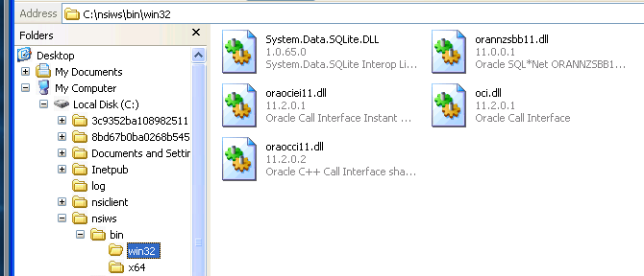
Figure 2 - 32bit Oracle DLLs copied in the 32bit specific folder

- The second option for configuring the Instant Client is to setup the NSI WS web.config “path” option (see section 4.8-“Miscellaneous database configuration options”) and set it to the Instant Client folder. E.g. “c:\instant_client_64bit”.
NOTE: Only one of the options should be used.

- For using the Oracle .net driver (Oracle.DataAccess.Client), ODP.NET the ODAC package is required. This can be found at:
http://www.oracle.com/technetwork/topics/dotnet/downloads/index.html
There are two flavours of the ODAC package, one with installer and another for xcopy deployment. Sometimes only the xcopy version is available. The installation instructions can be found in:
http://www.oracle.com/technetwork/topics/dotnet/tech-info/index.html

As a summary, the installation steps for installing the ODP.NET for .NET 4.0 are following:
- Run the CMD command as Administrator
- In the CMD window change the directory to the directory that ODAC xcopy package was installed. E.g. cd c:\odac_xcopy
- In the CMD window run install.bat all c:\oracle odac

In order to make the NSI WS use the ODP.NET driver for Dissemination Databases you need to set the defaultOracleProvider variable from web.config file. (see section 4.8-“Miscellaneous database configuration options”).

In a nutshell, in order to enable the Mapping Assistant populate the Mapping Store, the database should be created with the instructions in the annexes.
NOTE: The reader should create a database schema and a user with read and write access to that schema. The user should also exclude the part of instructions about the population from a DDL script, as the Mapping Assistant populates the Mapping Store Database. The Mapping Assistant must be installed prior the NSI Web Service, in order to populate the Mapping Store database. In order to set up a Mapping Store the user should follow the instructions in the Mapping Assistant Installation Guide
NOTE: After any driver installation or PATH environment modification (required by Oracle Instant Client) be sure to restart the IIS in order to incorporate the changes.

Reference Documents and Standards
The following documents, delivery packages and standards are applicable references:
Delivery packages
[R1] http://circa.europa.eu/Public/irc/dsis/stne/library?l=/x-dis/tools/reference_architecture/testauthclient/net&vm=detailed&sb=Title

Package Contents

The NSI WS package includes:
- The app directory contains the application and additional files for the installation.
- The doc directory contains the present document
- The src directory contains the source code
- The lib directory contains the required dll libraries

The app directory package comprises the following files:
- bin\Org.Sdmx.Resources.SdmxMl.Schemas.V10.dll – xml objects from SDMX 1.0
- bin\Org.Sdmx.Resources.SdmxMl.Schemas.V20.dll – xml objects from SDMX 2.0
- bin\Org.Sdmx.Resources.SdmxMl.Schemas.V21.dll – xml objects from SDMX 2.1
- bin\DataRetriever.dll – the file for the data retriever building block
- bin\Controllers.dll – The file for the controller library.
- bin\NsiWsSoap.dll – The file for the WCF SOAP services.
- bin\NsiWsRest.dll – The file for the WCF REST services.
- bin\StaticWsdlLoader.dll – The file for the helper code for loading static WSDL files.
- bin\log4net.dll – helper module to log the information
- bin\NSIWebService.dll - the file for the NSI web service building block
- bin\ MappingStoreRetrieval.dll –objects representing the SDMX ML model
- bin\PcAxis.dll – helper module to allow interaction with PcAxis files
- bin\StructureRetriever.dll - the file for the Structure Retriever building block
- bin\SdmxSoapValidatorExtension.dlll - the file for a helper library of the NSIWebService
- bin\ SdmxApi.dll – Common API interfaces
- bin\ SdmxDataParser.dll – Common API data parser
- bin\ SdmxObjects.dll - Common API objects implementation
- bin\ SdmxParseBase.dll – base classes of Common API parsers
- bin\ SdmxSourceUtil.dll – helper class of Common API
- bin\ SdmxStructureMutableParser.dll – Common API structure parser of mutable objects
- bin\ SdmxStructureRetrieval.dll – Common API structure retrieval
- bin\ TabularWriters.dll – helper class for writing tabular data
- bin\ Xml.Schema.Linq.dll – helper class for serialazing and deserialazing Common API objects
- bin\ EstatSdmxSourceExtension.CustomRequests.dll – custom implementation for ESTAT of structure parser
- bin\ SdmxXmlConstants.dll – library containing XML constants used in sdmx processing
- bin\ Estat.Nsi.AuthModule.dll – authentication library

- NSIEstatV20Service.asmx - web service definition file which uses SDMX v2.0 with ESTAT extensions and corrections.
- NSIStdV20Service.asmx - web service definition file which uses the standard SDMX v2.0
- Default.aspx – The informational index page
- Web.config - web service configuration file
- log4net.config – logging configuration file
- sdmx_org – folder that contain all SDMX-ML v2.0 XSDs
- sdmx_estat – folder that contain all SDMX-ML v2.0 XSDs wit hESTAT corrections.
- bin\win32 – the 32bit folder. This folder is added to the path automatically when running on 64bit Windows or as a 32bit program
- bin\x64 – the 64bit folder. This folder is added to the path automatically when running on 64bit Windows and as 64bit program. Note that IIS on 64bit Windows runs as a 64bit program.
The NSI Web Service is based on the following libraries provided by several companies including Microsoft and Oracle Systems:
- bin\win32\System.Data.SQLite.dll – The 32bit SqlLite database engine and a complete ADO.NET provider for SqlLite database
- bin\x64\System.Data.SQLite.dll – The 64bit SqlLite database engine and a complete ADO.NET provider for SqlLite database.
- bin\edtFTPnet.dll – helper module for working with FTP protocol

Installation procedure
In order to deploy the NSI Web Service on IIS you need to perform the following steps:

IIS Installation
Note: In order to allow access to the Web Service, please make sure the ports IIS is running are open in your firewall allowing both inbound and outbound traffic. The default ports are 80 for HTTP and 443 for HTTPS.

Installing on Windows Server
Additional server roles are needed for a standard IIS installation on Windows Server OS (e.g. Windows Server 2008). The user must verify with the Server Manager that the "Role Services" for the Web Server are enabled:
- Right click on "Web Server" in the "Roles" folder and select "Add Role Services":
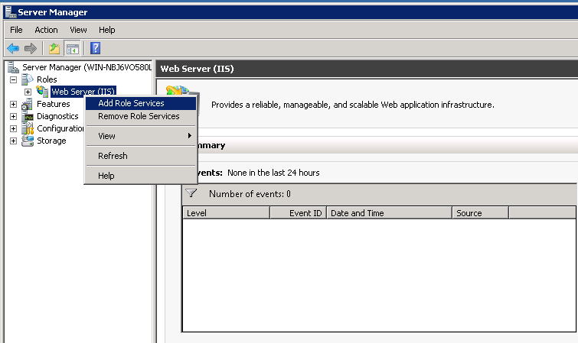
Figure 3: Server Manager – Add Role Services
- Follow the wizard steps and when the “Select Role Services” screen is display check the available options like in the screens below:
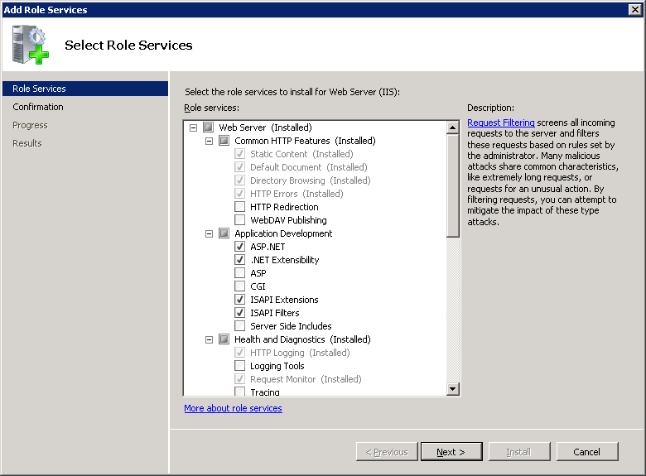
Figure 4: Role Services check boxes –part 1
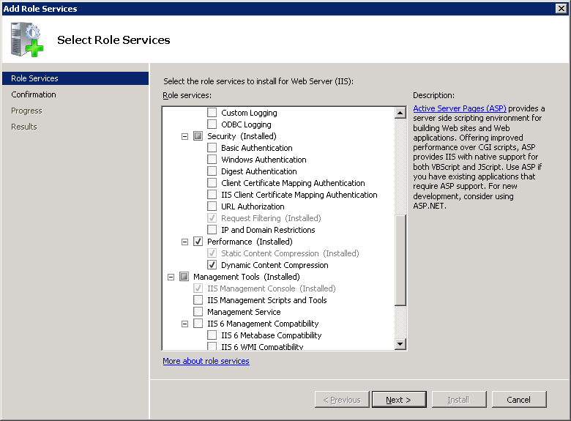
Figure 5: Role Services check boxes –part2
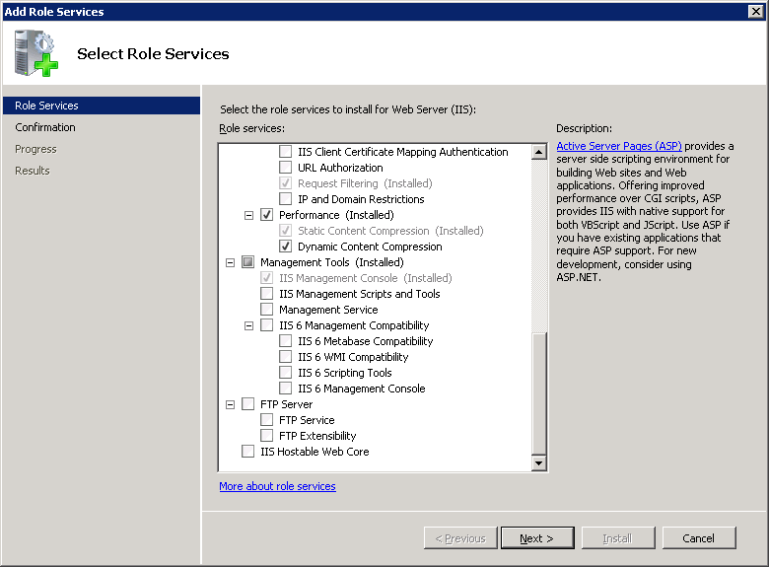
Figure 6: Role Services check boxes –part 3
- Click “Install” button.

Installing on Windows XP
The development web server that is compatible with Windows XP, IIS 5.1, is no longer supported. Alternative for testing and/or development on Windows XP the IIS Express 7.5 could be used.

NET Framework 4.0 installation and registration

The installation and registration of .NET Framework 4.0 with IIS must be verified.
To verify the .NET Framework installation, check if the folder "aspnet_client" is present in the "wwwroot" directory of the IIS and within "Default Web Site" (using Internet Information Service Manager).

IMPORTANT: .NET Framework version 4.0 on each computer has to be in line with the installed OS/hardware for the version in 32-Bit or 64-Bit.

If the .NET Framework 4.0 is not registered, the registering command has to be launched using command prompt from the .NET Framework’s folder:
- For 32-bit OS the 32-bit version of asp.net must be registered on IIS: C:\WINDOWS\Microsoft.NET\Framework\v4.0.30319\aspnet_regiis.exe –i –enable
- For 64-bit OS the 64-bit version of asp.net must be registered on IIS:
C:\WINDOWS\Microsoft.NET\Framework\v4.0. 30319\aspnet_regiis.exe –i –enable
After the success message is displayed the Internet Information Service (IIS) requires a reset to finalise the registration of the framework: type “iisreset” in command prompt.

Default Application Pool
The.NET Framework for the IIS "Default Application Pool” must be defined as follows:
- In IIS Manager, go to Applications Pools, select the properties of the "Default Application Pool" and verify or select the correct ".NET Framework v4.0" in "Integrated" mode:
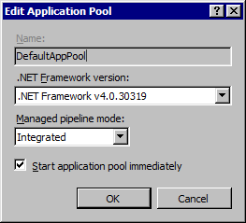
Figure 7: IIS Manager Screen
Start the "Default Application Pool" with the “Start” option of the "Application Pool Tasks" in the right column.

HTTP compression
To optimize the data transfer between NSI web service and its clients the HTTP compression (GZip) should be enabled.
To enable the HTTP compression, please follow the instructions:
- For IIS 6:
  - In IIS Manager, double-click the local computer, right-click the Web Sites folder, and then click Properties.
  - Click the Service tab, and in the HTTP compression section, select the Compress application files check box to enable compression for dynamic files.
  - Select the Compress static files check box to enable compression for static files
  - In the Temporary directory box, type the path to a local directory or click Browse to locate a directory. Once a static file is compressed, it is cached in this temporary directory until it expires, or the content changes. The directory must be on the local drive of an NTFS–formatted partition. The directory cannot be compressed or shared, and the access control lists (ACLs) for the directory must include Full Control access to the identity of the application pool or to the IIS_WPG group
  - Under Maximum temporary directory size, click a folder size option. If you specify a maximum size under Limited to (in megabytes) (the default setting is 95 MB), then when the limit is reached, IIS automatically cleans up the temporary directory by applying the "least recently used" rule.
  - Click Apply, and then click OK.
For more details please check Microsoft Website
- For IIS(7.x):
- Open IIS Manager and navigate to the level you want to manage. For information about opening IIS Manager, see Open IIS Manager (IIS 7)
- In Features View, double-click Compression
- On the Compression page, select the box next to Enable dynamic content compression.
- On the same tab please
- Click Apply in the Actions pane
For more details please check Microsoft Website
- For IIS (7.x) compression with REST and SDMX mime-types (application/vnd.smx, etc.):
  - Open IIS Manager and navigate to the level you want to manage. For information about opening IIS Manager, see Open IIS Manager (IIS 7)
  - In Features View, double-click Configuration.
  - At Section select system.webServer/httpCompression.
  - At dynamicTypes click at the Edit items.
  - To add a new mime type click at Add and then set Enabled to True and enter at the mimeType a mime type. This step needs to be repeated for each of the following mime types:
application/xml
application/vnd.sdmx.structure+xml
application/vnd.sdmx.genericdata+xml
application/vnd.sdmx.structurespecificdata+xml

- Close the window when done.
- Click Apply in the Actions pane
For more information see IIS Documentation
Note that HTTP compression is not supported by IIS 5.1 running under Windows Xp. See: Microsoft Website

Creating the Virtual Directory on 6.x
In order to install the NSI Web Service, a Virtual Directory should be created on the IIS
- Click Start, point to Programs, click to select Administrative Tools, and then click Internet Services Manager.
- Expand the server name.
- In the left pane, right-click Default Web Site, point to New, and then click Virtual Directory.
- In the first screen of the Virtual Directory Creation Wizard, type an alias, or name, for the virtual directory (such as NSIWS), and then click Next.
- In the second screen, click Browse. Locate the content folder that you will used to hold the content (such as C:\Inetpub\wwwroot\nsiws). Click Next.
- In the third screen, select Read and Run scripts (such as ASP). Make sure that the other check boxes are cleared. Click Finish to complete the wizard.
- To confirm that an application was created, right-click the new virtual directory, and then click Properties.
- On the Virtual Directory tab, make sure that the virtual directory name is listed in the Application Name box under Application Settings. If it is not, click Create. Note that the application name does not have to match the virtual directory alias.
- On the ASP.NET tab make sure that the ASP.NET version is set to 4.0
- Close the Properties dialog box.
- Click the “Configuration...” button in the Virtual Directory tab and under “Wildcard application maps (order of implementation)” click the “Insert....” button.
- Select as Executable the aspnet_isapi.dll from the .NET framework that are using e.g. :
C:\Windows\Microsoft.NET\Framework64\v4.0.30319\aspnet_isapi.dll (64bit)
C:\Windows\Microsoft.NET\Framework\v4.0.30319\aspnet_isapi.dll (32bit)
- Un-check the “Verify that file exists” checkbox and press OK
- Close the Properties dialog box

Creating the Application on IIS 7.x
In order to install the NSI Web Service, an Application should be created on the IIS:
- Click Start, point to Programs, click to select Administrative Tools, and then click Internet Services Manager.
- Expand the server name.
- In the left pane, right-click Default Web Site, point to Add Application.
- In the first text box, type an alias, or name, for the virtual directory (such as NSIWS)
- In the second text box, click Browse. Locate the content folder that will be used to hold the content (such as C:\Inetpub\wwwroot\nsiws)
- Make sure that the Application Pool is a ASP.NET 4.0 - integrated mode.
- Click ok to finish.

Application Preparation

Copying the files
Copy the contents of the app directory from the release package to the folder that you will use to hold the content (such as C:\Inetpub\wwwroot\nsiws).
Please note that the contents should not be copied to the root IIS folder, usually ‘wwwroot’, as it is a special folder for ASP.NET.

Configure web.config
The Web Service application obtains the configuration parameter from the web.config file.
Although the configuration file looks rather big, the most important configuration elements are the logging file, the connection string and the default header values.

Verification of the deployment
The reader should try to access the informational index page of the deployed web service through a browser.
E.g. http://domain:port/virtualdirectory/default.aspx .
If the informational index page is retrieved correctly, then the deployment was successful.
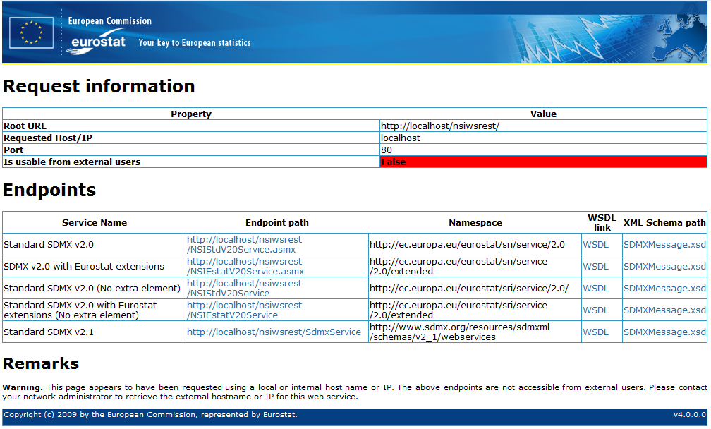
Figure 8 – Index page (when accessed from localhost)
Note: In the informational index page, the requested URL is parsed in order to determine if this URL is usable to external users. The requested URL is the URL entered to access the index page. For example a URL that contains ‘localhost’ as the hostname will not be usable to external users or even intranet users as ‘localhost’ is the always the local machine. A URL that contains a private IP like 192.168/16 will probably be usable by intranet users but not for external users. But sometimes a host name will resolve to a private IP address when accessed within the organization and internet IP address when accessed by externals users.

REST base URL
The base URL for REST is /rest e.g:
http://domain:port/virtualdirectory/rest/

Logging configurations
<log4net>
<appender name="RollingFile" type="log4net.Appender.RollingFileAppender">
<file value="App_Data\nsi-ws.log"/>
<rollingStyle value="Date"/>
<datePattern value="yyyyMMdd"/>
<appendToFile value="true"/>
<layout type="log4net.Layout.PatternLayout">
<conversionPattern value="%level %logger %date{ISO8601} - %message%newline"/>
</layout>
</appender>
<root>
<level value="DEBUG"/>
<appender-ref ref="RollingFile"/>
</root>
</log4net>

The above setting is configured in log4net.config file.
The most important attribute to be configured for the log is the file name; in the above example the configured value is “App_Data/nsi-ws.log”. The user could modify this with any valid filename and should in production installations. If the file does not exist, the logging module will create a new file and will log into it. If the file already exists, then the logging module will continue to log at the end of it.
Please note that in order for the log file to be created and/or append log events to an existing log file, the file system permissions must allow this.
The level node controls whether logging is enabled and what level of messages should it record. The list of possible values can be found in the following table:
Setting | Description
Off | Turn off logging
FATAL | Log only critical level messages
ERROR | Log only critical and error messages
WARN | Log only critical, error and warning messages
INFO | Log information, warning, error and fatal messages
DEBUG | Log debug messages and above (Info, Warn, Error and Fatal)
ALL | Log all messages

The other settings are related with the format of the log entry, which by default is configured to contain the following:
- Timestamp of the log entry;
- Rolling style: when a new log file is created and the old one is archived
- Pattern layout: what and how the log information is written in the log file
- Message containing the description of the log entry generated event;
More information can be found at the Apache log4net website at:
http://logging.apache.org/log4net/release/config-examples.html
The Apache log4net is developed by the Apache Software Foundation and more detailed information including description, features, how-to and documentation can be found at the Apache log4net web site at:
http://logging.apache.org/log4net/

Connection string to the Mapping Store database server
The configuration element is used to define the connection string to the Mapping Store Database Server is defined in the connectionString section of the web.config. An example of the connection string is:
<configuration>
<connectionStrings>
<add name="MappingStoreServer"
connectionString="Data Source=.\SQLEXPRESS;
Initial Catalog=MADB;
Integrated Security=True"
providerName="System.Data.SqlClient"/>

The element contains 3 attributes:
- name: defines the name of the connection string and must always be “MappingStoreServer”. The application searches for this name in order to connect to the Mapping Store Database Server.
- connectionString: defines the connection string that the application is using in order to connect to the database server. This string varies depending on the database server (e.g. Microsoft SQL Server, Oracle, MySql Server)
- providerName: defines the client that will be used by the application in order to connect to the database server. The accepted values for this attribute are:
  - for Microsoft SQL Server: System.Data.SqlClient
  - for Oracle Server: System.Data.OracleClient or Oracle.DataAccess.Client
  - for MySQL Server: MySql.Data.MySqlClient
For each of the database servers the connection string element may have the values presented bellow.

The connectionString element for Microsoft SQL Server
<connectionStrings>
<add name="MappingStoreServer"
connectionString="Data Source=.\SQLEXPRESS;Initial Catalog=MADB; Integrated Security=True"
providerName="System.Data.SqlClient"/>
</connectionStrings>

The connectionString element for Oracle Database Server
<connectionStrings>
<add name="MappingStoreServer"
connectionString="Data Source=localhost/XE;User ID=sis;Password=sis"
providerName="System.Data.OracleClient" />
</connectionStrings>

OR

<connectionStrings>
<add name="MappingStoreServer"
connectionString="Data Source=localhost/XE;User ID=sis;Password=sis"
providerName="Oracle.DataAccess.Client" />
</connectionStrings>

The connectionString element for MySql Server
<connectionStrings>
<add name="MappingStoreServer" connectionString="server=127.0.0.1;user id=root;password=123456;database=MADB"
providerName="MySql.Data.MySqlClient"/>
</connectionStrings>

Authentication/Authorization support
By default authentication and authorization is disabled. In order to add authentication and authorization support, the following changes must be applied to the web.config file:
First the Authentication/Authorization module needs to be enabled.
For IIS 5.x/6.x or IIS 7.x with classic pool this is achieved by adding the NsiAuthModule under system.web/httpModules:
web.config (IIS 5.x/6.x)
<system.web>
…
<httpModules>
…
<add name="NsiAuthModule" type="Estat.Nsi.AuthModule.NsiAuthModule, Estat.Nsi.AuthModule"/>
For IIS 7.x this is achieved by adding the NsiAuthModule under system.webServer/modules:
web.config (IIS 7.x)
<system.webServer>
<validation validateIntegratedModeConfiguration="false"/>
<modules>
…
<add name="NsiAuthModule" type="Estat.Nsi.AuthModule.NsiAuthModule, Estat.Nsi.AuthModule" />
Then the NsiAuthModule configuration needs to be modified in the web.config file. The NsiAuthModule configuration section is available under “estat.nsi.ws.config” element, in the “auth” element.
web.config
<estat.nsi.ws.config>
<auth anonymousUser="anon" realm="nsiws">
<userCredentialsImplementation type="Estat.Nsi.AuthModule.UserCredentialsHttpBasic, Estat.Nsi.AuthModule" />
<authenticationImplementation type="Estat.Nsi.AuthModule.DbAuthenticationProvider, Estat.Nsi.AuthModule" />
<userImplementation type="Estat.Nsi.AuthModule.UserPassThrough, Estat.Nsi.AuthModule" />
<authorizationImplementation type="Estat.Nsi.AuthModule.DbAuthorizationProvider, Estat.Nsi.AuthModule" />
<dbAuth>
<authentication sql="select password from users where userid=${user}" connectionStringName="authdb"/>
<authorization sql="select d.id as ${id}, d.ver as ${version}, d.agency as ${agencyId} from users u inner join user_df ud on u.pk=ud.user_pk inner join dfs d on d.pk = ud.df_pk where u.userid=${user}" connectionStringName="authdb"/>
</dbAuth>
</auth>
</estat.nsi.ws.config>

The list of possible configuration options for the NsiAuthModule can be found in the following table:
XML Element/Attribute | Description
auth/anonymousUser | Include this XML attribute with any value to allow access of anonymous user to WSDL and the following structural metadata:  - Category Schemes,  - ConceptSchemes,  - Codelists,  - Hierarchical Codelists  - KeyFamily.  In order to allow the anonymous user to access certain data and certain dataflows then this XML attribute value must be the username of a valid user for Authorization.  Please note that in some cases, the client will send user credentials only when requested from the server side. When the anonymousUser is set the clients will not receive the request to authenticate from the server. In such cases the client must support and be configured to send the user credentials pre-emptively.
auth/realm | The realm or the domain. This is required by some implementations which retrieve credentials from HTTP headers.
userCredentialsImplementation/type | The implementation of IUserCredentials interface. This implementation will be used to retrieve user credentials, in most cases UserName and Password.
authenticationImplementation/type | The implementation of the IAuthenticationProvider interface.  This implementation will be used for authentication.
userImplementation/type | The implementation of the IUser interface. This implementation will be used for storing the user credentials and comparing passwords.
authorizationImplementation/type | The implementation of the IAuthorizationProvider interface.  This implementation will be used for authorization.  In case the IAuthenticationProvider implementation provides a default IAuthenticationProvider this element is optional but it will be used if configured.
Together with the NsiAuthModule(Estat.Nsi.AuthModule), at least one implementation for each interface is included. The table below contains the list of implementations currently included in the NsiAuthModule and can be used as values to the corresponding “type” XML attribute discussed in the above table.
Interface | Type | Description
IUserCredentials | Estat.Nsi.AuthModule.UserCredentialsHttpBasic, Estat.Nsi.AuthModule | This implementation retrieves the user credentials from HTTP Headers using Basic Authentication.
IAuthenticationProvider | Estat.Nsi.AuthModule.DbAuthenticationProvider, Estat.Nsi.AuthModule | This implementation will retrieve the authentication information from a database. It does not require a specific schema and the SQL Query used to retrieve the authentication information is configurable.
IUser | Estat.Nsi.AuthModule.UserPassThrough, Estat.Nsi.AuthModule | This implementation will not encrypt or encode/decode the password. This implementation can be used when the password is retrieved by the IAuthenticationProvider in the same form as it is retrieved from IUserCredentials.
IUser | Estat.Nsi.AuthModule.UserMD, Estat.Nsi.AuthModule | This implementation will encrypt the password to MD5 before comparing it to the password retrieved by the IAuthenticationProvider
IAuthorizationProvider | Estat.Nsi.AuthModule.DbAuthorizationProvider, Estat.Nsi.AuthModule | This implementation will retrieve authorization information from the database. It does not require a specific schema and SQL Query used to retrieve the authentication information is configurable.

The DbAuthenticationProvider/DbAuthorizationProvider implementations require additional configuration. The configuration section is located under “estat.nsi.ws.config” element, in the “auth” element, at “dbAuth”.
An example on how to use DbAuthenticationProvider/DbAuthorizationProvider implementations can be found in Annex A: Authentication/Authorization sample database schema.
The authentication/authorization database can be configured using the TestAuthConfig tool. A short description of the TestAuthConfig tool can be found in the “SDMX-RI Overview” document. For installing TestAuthConfig please refer to the “Installing TestAuthConfig”. For using TestAuthConfig please refer to the “User Manual of the TestAuthConfig”.
Note:Currently the DbAuthenticationProvider/DbAuthorizationProvider implementations do not use the “path” configuration option, see section “Miscellaneous database configuration options”, and ignore any DLL under the bin\win32 and bin\X64 folders.
The list of possible configuration options for the DbAuthenticationProvider/ DbAuthorizationProvider implementations can be found in the following table:
XML Element/Attribute | Description
dbAuth/authentication/sql | The SQL SELECT statement to retrieve the password for a user. The password needs to be the first and only returned column.  The SELECT statement needs to have a clause that compares the username field against the parameter ${user}. The ${user} parameter is used internally and is expanded to a user name. The ${user} parameter can appear multiple times.  e.g.  select password from users where userid=${user}
dbAuth/authentication/ connectionStringName | The Database Connection string name. Needs to be a valid connection string name with the corresponding configuration in the <connectionStrings> of the web.config file. The connection string will be used to connect to the authentication database.
dbAuth/authorization/sql | The SQL SELECT statement to retrieve the allowed dataflows for a user. The only fields that are required are the dataflow id, dataflow version and dataflow agency. Those fields need to use specific aliases using the ‘AS’ keyword. Specifically:  - The dataflow Id field should use the alias ${id}  - The version field should use the alias ${version}  - The agency Id field should use the alias ${agencyId}  Those aliases are used internally to determine which the dataflow id, version and agency columns are.  The SELECT statement needs to have a clause that compares the username field against the parameter ${user}. The ${user} parameter is used internally and is expanded to a user name. The ${user} parameter can appear multiple times.  e.g.  select d.id as ${id}, d.ver as ${version}, d.agency as ${agencyId} from users u inner join user_df ud on u.pk=ud.user_pk inner join dfs d on d.pk = ud.df_pk where u.userid=${user}
dbAuth/ authorization / connectionStringName | The Database Connection string name. Needs to be a valid connection string name with the corresponding configuration at <connectionStrings> at the web.config file. The connection string will be used to connect to the authorization database.  This setting is optional. If it’s not set, the dbAuth/authentication/connectionStringName will be used instead.

Miscellaneous database configuration options
The settings for each database vendor can be specified in the Web.Config. There are two types of settings:
- The general “DatabaseSettings” which apply to both MappingStore (MSDB) and Dissemination (DDB) databases.
- The “ddbSettings” are for mapping the DDB provider names to .NET database providers/drivers.
web.config
<configSections>
….
<sectionGroup name="estat.sri">
<section name="mapping.store" type="Estat.Sri.MappingStoreRetrieval.Config.MappingStoreConfigSection, MappingStoreRetrieval" />
</sectionGroup>
</configSections>
…

<estat.sri>
<mapping.store>
<DatabaseSettings>
<clear/>
<add provider="System.Data.SqlClient" subStringCmd="SUBSTRING" subStringNeedsLength="true" parameterMarkerFormat="@{0}" castToStringFormat="CAST({0} AS VARCHAR)" subQueryOrderByAllowed="false"/>
<add provider="Oracle.DataAccess.Client" parameterMarkerFormat=":{0}" dateCast="DATE" />
<!-- Please note that System.Data.OracleClient is obsolete and no longer maintained by Microsoft. -->
<add provider="System.Data.OracleClient" parameterMarkerFormat=":{0}" dateCast="DATE" />
<add provider="MySql.Data.MySqlClient" parameterMarkerFormat="@{0}" dateCast="DATE" />
<!-- DDB only providers -->
<add provider="org.estat.PcAxis.PcAxisProvider" parameterMarkerFormat="@{0}" />
<!-- ODBC options depend on the ODBC driver used. -->
<add provider="System.Data.Odbc" parameterMarkerFormat="?" subStringCmd="SUBSTRING" subStringNeedsLength="true" castToStringFormat="CAST({0} AS VARCHAR)" subQueryOrderByAllowed="false" />
</DatabaseSettings>
<!-- Dissemination Database (DDB) settings only -->
<!-- Options are: -->
<!-- name : The DDB provider name. Mandatory and unique. -->
<!-- provider : The .NET DB Provider name. -->
<ddbSettings>
<clear/>
<add name="SqlServer" provider="System.Data.SqlClient" />
<add name="Oracle" provider="Oracle.DataAccess.Client" />
<add name="PCAxis" provider="org.estat.PcAxis.PcAxisProvider" />
<add name="MySQL" provider="MySql.Data.MySqlClient" />
<add name="Odbc" provider="System.Data.Odbc" />
</ddbSettings>
</mapping.store>
</estat.sri>
The “DatabaseSettings” options are:
Option | Default Value | Description
provider | None. | The ADO.NET database provider name. It is mandatory and must be unique.
subStringCmd | SUBSTR | The substring command for this provider.
subStringNeedsLength | false | A value indicating whether the substring for this provider requires a length parameter.
parameterMarkerFormat | None | The named parameter format for this provider. This is used to create the parameter names inside an SQL statement and for naming the DbParameter objects. It needs to be specified. This format will be used with string.Format (or similar methods) with one parameter.
castToStringFormat | {0} | The format string that should be used to cast to string the specified field. The field is specified in the format parameter. . This format will be used with string.Format (or similar methods) with one parameter.
subQueryOrderByAllowed | true | A value indicating whether an SQL sub-query can have an ORDER BY.
dateCast | “” (empty string) | The required by the provider prefix for casting to date type.

The “ddbSettings” options are:
Option | Default Value | Description
provider | None. | The ADO.NET database provider name. It is mandatory.
name | None | It is mandatory and must be unique.

The following configuration options are normally not needed but might be required in case of issues with database drivers:
Setting | Description
path | Adds the specified path to beginning of the PATH environment variable. Multiple path can be added and should be separated by a semi-colon ‘;’.
defaultDDBOracleProvider | Set the default data provider to use for Oracle Dissemination Databases. The default is “System.Data.OracleClient”. Other possible value is “Oracle.DataAccess.Client”.  In case the mapping store is also an Oracle Database this option is ignored.
Normally they are commented out (disabled).
Please note that “defaultDDBOracleProvider” setting is obsolete, use ddbSettings instead:.
<appSettings>
…
<add key="path" value="c:\oracle\bin"/>
<!-- The following setting is obsolete. Please use ddbSettings-->
<add key="defaultDDBOracleProvider" value="Oracle.DataAccess.Client"/>

Configuration of the default header values
The configuration element is used to define various values of a default header that the application will use in case no other header is defined in the mapping assistant. The settings names correspond to the Header element as defined by SDMX standard.

<Estat.Nsi.DataDisseminationWS.HeaderSettings>
<setting name="id" serializeAs="String">
<value>IT1001</value>
</setting>
<setting name="test" serializeAs="String">
<value>true</value>
</setting>
<setting name="truncated" serializeAs="String">
<value>false</value>
</setting>
<setting name="name" serializeAs="String">
<value>Trans46302</value>
</setting>
<setting name="prepared" serializeAs="String">
<value>2001-03-11T09:30:47-05:00</value>
</setting>
<setting name="senderid" serializeAs="String">
<value>ISTAT</value>
</setting>
<setting name="sendername" serializeAs="String">
<value>Italian Statistical Institute</value>
</setting>
<setting name="sendercontactname" serializeAs="String">
<value>Francesco Rizzo</value>
</setting>
<setting name="sendercontactdepartment" serializeAs="String">
<value>Statistics</value>
</setting>
<setting name="sendercontactrole" serializeAs="String">
<value>IT Staff</value>
</setting>
<setting name="sendercontacttelephone" serializeAs="String">
<value>210 2222222</value>
</setting>
<setting name="sendercontactfax" serializeAs="String">
<value>210 00010999</value>
</setting>
<setting name="sendercontactx400" serializeAs="String">
<value />
</setting>
<setting name="sendercontacturi" serializeAs="String">
<value>http://www.sdmx.org</value>
</setting>
<setting name="sendercontactemail" serializeAs="String">
<value>rizzo@istat.it</value>
</setting>
<setting name="receiverid" serializeAs="String">
<value>ESTAT</value>
</setting>
<setting name="receivername" serializeAs="String">
<value>Eurostat</value>
</setting>
<setting name="receivercontactname" serializeAs="String">
<value>Bengt-Ake Lindblad</value>
</setting>
<setting name="receivercontactdepartment" serializeAs="String">
<value>Information Technology</value>
</setting>
<setting name="receivercontactrole" serializeAs="String">
<value>IT Staff</value>
</setting>
<setting name="receivercontacttelephone" serializeAs="String">
<value>210 1234567</value>
</setting>
<setting name="receivercontactfax" serializeAs="String">
<value>210 3810999</value>
</setting>
<setting name="receivercontactx400" serializeAs="String">
<value>lalala</value>
</setting>
<setting name="receivercontacturi" serializeAs="String">
<value>http://www.sdmx.org</value>
</setting>
<setting name="receivercontactemail" serializeAs="String">
<value>bengt-ake.lindblad@ec.europa.eu</value>
</setting>
<setting name="datasetagency" serializeAs="String">
<value>BIS</value>
</setting>
<setting name="datasetid" serializeAs="String">
<value>ISTAT_JD_237</value>
</setting>
<setting name="datasetaction" serializeAs="String">
<value>Append</value>
</setting>
<setting name="extracted" serializeAs="String">
<value>2001-03-11T09:30:47-05:00</value>
</setting>
<setting name="reportingbegin" serializeAs="String">
<value>2000-12-01T00:00:00</value>
</setting>
<setting name="reportingend" serializeAs="String">
<value>2006-01-01T00:00:00</value>
</setting>
<setting name="source" serializeAs="String">
<value>source</value>
</setting>
<setting name="lang" serializeAs="String">
<value>en</value>
</setting>
<setting name="keyfamilyref" serializeAs="String">
<value>kfRef</value>
</setting>
<setting name="keyfamilyagency" serializeAs="String">
<value>kfAg</value>
</setting>
</Estat.Nsi.DataDisseminationWS.HeaderSettings>
</applicationSettings>

Un-installation procedure

Remove virtual directory from IIS 5.1/6.x

In order to un-install the NSI Web Service, the Virtual Directory (such as NSIWS) should be removed from the IIS.
- Click Start, point to Programs, click to select Administrative Tools, and then click Internet Services Manager.
- Expand the server name.
- Expand the “Default Web Site”.
- In the left pane, right-click at the virtual directory (such as NSIWS) and then click Delete
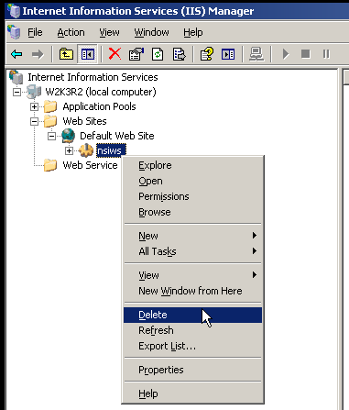
Figure 9 – IIS 5.x/6.x. Delete virtual directory
- Click Yes.
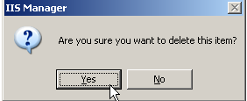
Figure 10 – Confirm IIS 5.x/6.x virtual directory removal

Note Removing an application in IIS does not delete the physical content from the Windows file system; it removes the relationship of the content as an application under a site.

Remove application from IIS 7.x
In order to un-install the NSI Web Service, the Application (such as NSIWS) should be removed from the IIS
- Click Start, point to Programs, click to select Administrative Tools, and then click Internet Services Manager.
- Expand the server name.
- Expand the Sites, “Default Web Site
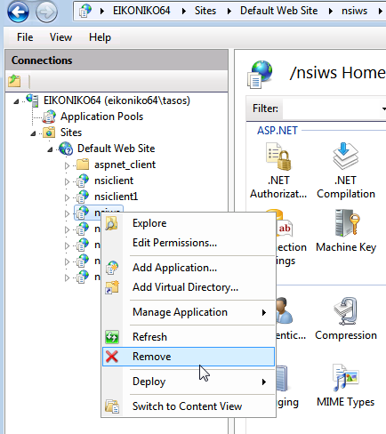
Figure 11 – IIS 7.x Right-Click menu, Remove selected application
- In the left pane, right-click at the application (such as NSIWS) and then click Remove.
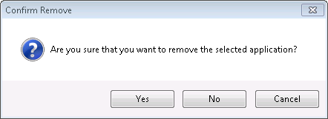
Figure 12 - Confirm IIS 7.x application remove
- Click Yes.
Note Removing an application in IIS does not delete the physical content from the Windows file system; it removes the relationship of the content as an application under a site.

Remove the content folder from Windows file system (all IIS versions)
After un-installing the NSI Web Service from the IIS, delete the content folder from the Windows file system (such as C:\Inetpub\wwwroot\nsiws) using for example Windows Explorer (see Figure 13).
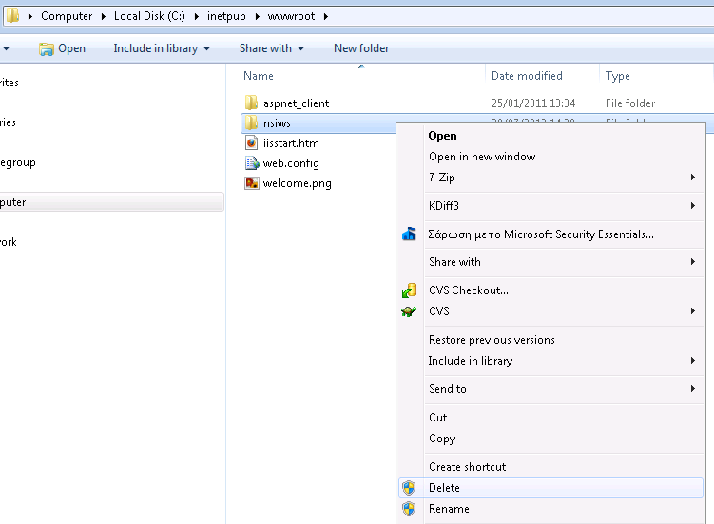
Figure 13 - Delete folder from Windows file system using Windows Explorer

Annex A: Authentication/Authorization sample database schema.
The DbAuth* Provider implementation does not require a specific database schema because the SQL SELECT statements used to retrieve authentication and authorization information is configurable. This sample database schema is provided in order to help to either build an authentication and/or authorization database schema or to integrate with an existing database.
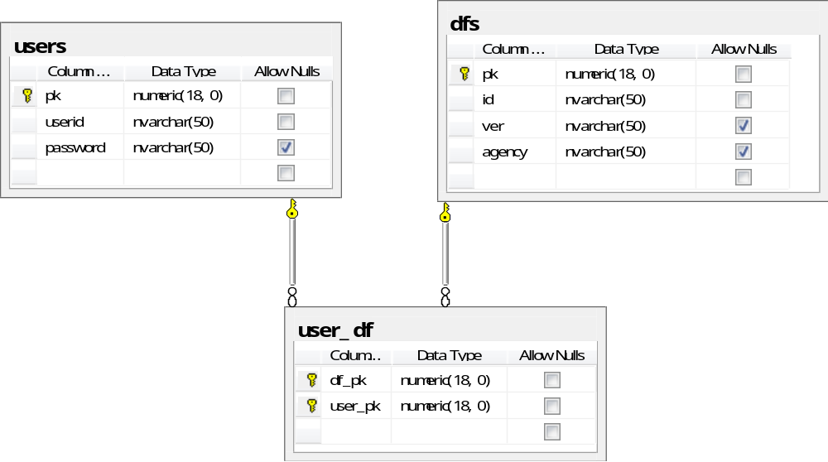
Figure 14- Authentication/Authorization sample database schema

The sample database schema consists from three tables (see Figure 14). The “users” table contains the primary key field (pk) the user name field (userid) and the password field. The dataflows table “dfs” contains the primary key field (pk), the dataflow id (id), version (ver) and agency Id (agency) fields. The table that connects the users and the dataflows is the “user_df” table. This table has two fields, the dataflow primary key (df_pk) and the user’s primary key (user_pk).
The primary key fields “pk” should be auto-incremented (MySQL), identity (SQL Server) or sequence (Oracle).
Please refer to the TestAuthConfig package for sample SQL scripts.

This database schema can be accessed by the DbAuth*Provider implementations using the following configuration:

web.config/estat.nsi.ws.config/auth
<dbAuth>
<authentication sql="select password from users where userid=${user}" connectionStringName="authdb"/>
<authorization sql="select d.id as ${id}, d.ver as ${version}, d.agency as ${agencyId} from users u inner join user_df ud on u.pk=ud.user_pk inner join dfs d on d.pk = ud.df_pk where u.userid=${user}" connectionStringName="authdb"/>
</dbAuth>

The “authdb” connection string name could point to a connection string e.g. an SQL Server database named authdatabase;

<connectionStrings>
<add name="authdb"
connectionString="Data Source=.\SQLEXPRESS;Initial Catalog=authdatabase; Integrated Security=True"
providerName="System.Data.SqlClient"/>
</connectionStrings>

Annex B: Recommend hardware specifications assumptions.
This section presents the details related with the performance test for 5 concurrent users retrieving 100000 observations with 5 second average response time for each user from which the recommended hardware specification of the NSI Web Service emerged (as specified in 1.1).
More specifically, the environment details (software, hardware, data) used for this measurement are presented

NSI Web Service server – specifications
Attribute | Value
CPU | Intel E8400 Core 2 at 3.00Ghz
OS | Windows 7 Pro 64bit
RAM | 4 GB of RAM
Application Server | Internet Information Server 7.5
Network interface | 1GbE

The dissemination database (DDB) runs on a different computer than NSI WS.

DDB and MADB server – specifications

Attribute | Value
CPU | Intel E8400 Core 2 at 3.00Ghz
OS | Fedora 15
RAM | 8 GB of RAM
Database Server | Oracle XE 11
Network interface | 1GbE

Please note that database schema together with the required indexes and constraints are a more important performance factor than the DDB hardware.
The dissemination database (DDB) runs on a different computer than NSI WS. The performance of the DDB executing the DR generated SQL Query is shown in the table below.

Attribute | Time
Execute SQL Query (no record) response time | <= 1sec
Retrieve all requested 100K records | <2sec
Table 2 – DDB performance when executing DR generated SQL query for 100K records

The DDB database scheme used was the following:

SQL (ANSI)
CREATE
TABLE "HC06_CY"
(
"COC" VARCHAR(6) NOT NULL,
"TIME_FORMAT" VARCHAR(3),
"OBS_STATUS" VARCHAR(1) NOT NULL,
"GEO" VARCHAR(5) NOT NULL,
"POB" VARCHAR(6) NOT NULL,
"AGE" VARCHAR(6) NOT NULL,
"OBS_VALUE" FLOAT,
"CAS" VARCHAR(6) NOT NULL,
"HC_NOTE" VARCHAR(4000),
"SEX" VARCHAR(1) NOT NULL,
"LMS" VARCHAR(5) NOT NULL,
"FREQ" VARCHAR(1) NOT NULL,
"OBS_LEVEL" VARCHAR(100),
"OBS_NOTE" VARCHAR(4000),
"TIME" VARCHAR(4) NOT NULL,
"FST" VARCHAR(5) NOT NULL,
PRIMARY KEY ("COC", "GEO", "POB", "AGE", "CAS", "SEX", "LMS", "FREQ",
"TIME", "FST")
);

CREATE INDEX indx_0 ON HC06_CY(COC);
CREATE INDEX indx_1 ON HC06_CY(GEO);
CREATE INDEX indx_2 ON HC06_CY(POB);
CREATE INDEX indx_3 ON HC06_CY(AGE);
CREATE INDEX indx_4 ON HC06_CY(CAS);
CREATE INDEX indx_5 ON HC06_CY(SEX);
CREATE INDEX indx_6 ON HC06_CY(LMS);
CREATE INDEX indx_7 ON HC06_CY(FREQ);
CREATE INDEX indx_8 ON HC06_CY(TIME);
CREATE INDEX indx_9 ON HC06_CY(FST);

The SQL Query that was generated and executed by DR (indicative, depends on data)

SQL (ANSI)
select HC06_CY1_COC, HC06_CY1_GEO, HC06_CY1_POB, HC06_CY1_AGE, HC06_CY1_OBS_VALUE, HC06_CY1_CAS, HC06_CY1_SEX, HC06_CY1_LMS, HC06_CY1_FREQ, HC06_CY1_TIME, HC06_CY1_FST
from (
select HC06_CY1.COC as HC06_CY1_COC, HC06_CY1.GEO as HC06_CY1_GEO, HC06_CY1.POB as HC06_CY1_POB, HC06_CY1.AGE as HC06_CY1_AGE, HC06_CY1.OBS_VALUE as HC06_CY1_OBS_VALUE, HC06_CY1.CAS as HC06_CY1_CAS, HC06_CY1.SEX as HC06_CY1_SEX, HC06_CY1.LMS as HC06_CY1_LMS, HC06_CY1.FREQ as HC06_CY1_FREQ, HC06_CY1.TIME as HC06_CY1_TIME, HC06_CY1.FST as HC06_CY1_FST
from HC06_CY HC06_CY1
) virtualDataset
where ( ( HC06_CY1_GEO = 'IT' ) AND ( ( HC06_CY1_TIME = '2011' )) AND ( ( HC06_CY1_AGE = 'Y1' ) OR ( HC06_CY1_AGE = 'Y2' ) OR ( HC06_CY1_AGE = 'Y3' ) OR ( HC06_CY1_AGE = 'TOTAL' ) ) AND ( ( HC06_CY1_SEX = 'M' ) OR ( HC06_CY1_SEX = 'F' ) OR ( HC06_CY1_SEX = 'T' ) ) AND ( ( HC06_CY1_POB = 'BE' ) OR ( HC06_CY1_POB = 'BG' ) OR ( HC06_CY1_POB = 'TOTAL' ) OR ( HC06_CY1_POB = 'CZ' ) OR ( HC06_CY1_POB = 'EU_OTH' ) OR ( HC06_CY1_POB = 'NAT' ) OR ( HC06_CY1_POB = 'FOR' ) ) AND ( ( HC06_CY1_CAS = 'INAC' ) OR ( HC06_CY1_CAS = 'ACT' ) OR ( HC06_CY1_CAS = 'EMP' ) OR ( HC06_CY1_CAS = 'UNE_NW' ) OR ( HC06_CY1_CAS = 'UNE' ) OR ( HC06_CY1_CAS = 'UNE_W' ) OR ( HC06_CY1_CAS = 'POP' ) ) AND ( ( HC06_CY1_COC = 'FOR' ) OR ( HC06_CY1_COC = 'EU_FOR' ) OR ( HC06_CY1_COC = 'TOTAL' ) OR ( HC06_CY1_COC = 'BE' ) OR ( HC06_CY1_COC = 'NAT' ) OR ( HC06_CY1_COC = 'BG' ) OR ( HC06_CY1_COC = 'CZ' ) ) AND ( ( HC06_CY1_FST = 'CPL' ) OR ( HC06_CY1_FST = 'TOTAL' ) OR ( HC06_CY1_FST = 'REP' ) OR ( HC06_CY1_FST = 'MAR' ) OR ( HC06_CY1_FST = 'MARO' ) OR ( HC06_CY1_FST = 'MARS' ) OR ( HC06_CY1_FST = 'REPO' ) ) AND ( ( HC06_CY1_LMS = 'MARO' ) OR ( HC06_CY1_LMS = 'DIV' ) OR ( HC06_CY1_LMS = 'TOTAL' ) OR ( HC06_CY1_LMS = 'MAR' ) OR ( HC06_CY1_LMS = 'MARS' ) ) )
order by HC06_CY1_FREQ, HC06_CY1_TIME, HC06_CY1_COC, HC06_CY1_AGE, HC06_CY1_GEO, HC06_CY1_POB, HC06_CY1_FST, HC06_CY1_SEX, HC06_CY1_CAS, HC06_CY1_LMS

Other assumptions can be found on the table below:

Assumption | Value
Number of records in database | 3529470
Number of concurrent users | 5
Size of the response message | 10MB
Observations (Cells) in response message | 102900
Requested SDMX-ML Format | GetCrossSectionalData
Transcodings tested (see Table 4) | 0%, 15% and 35%
Storage scheme type | Type A
Table 3 – Other recommended hardware assumptions

Trancoding | Description
0% | No transcoding
15% | 1 medium codelist (component COC) with 231 codes
35% | 1 medium codelist (component COC) with 231 codes  +  1 big codelist (component GEO) with 8237
Table 4 – Transcoding table

For more details about the Mapping Store database please see the SDMX RI Overview document.
For instance, Oracle is listening by default on port 1521 but this setting can be changed according to the local network rules and restrictions.
For more information regarding the Mapping Assistant tool and the Mapping Store database can be found at the SDMX RI Overview document.
The differences between the two oracle drivers are beyond the scope of this document. Some information can be found at http://www.oracle.com/technetwork/topics/dotnet/index-154765.html
This does not apply to IIS 7.5/8 Express edition. Please refer to IIS 7.5/8 Express instructions on how to add a new application by editing its configuration file.
Currently the database vendors supported are MS Sql Server, MySQL and Oracle.
This does not apply to IIS 7.5 Express edition. Please refer to IIS 7.5 Express instructions on how to remove an application by editing its configuration file.

